 |  | 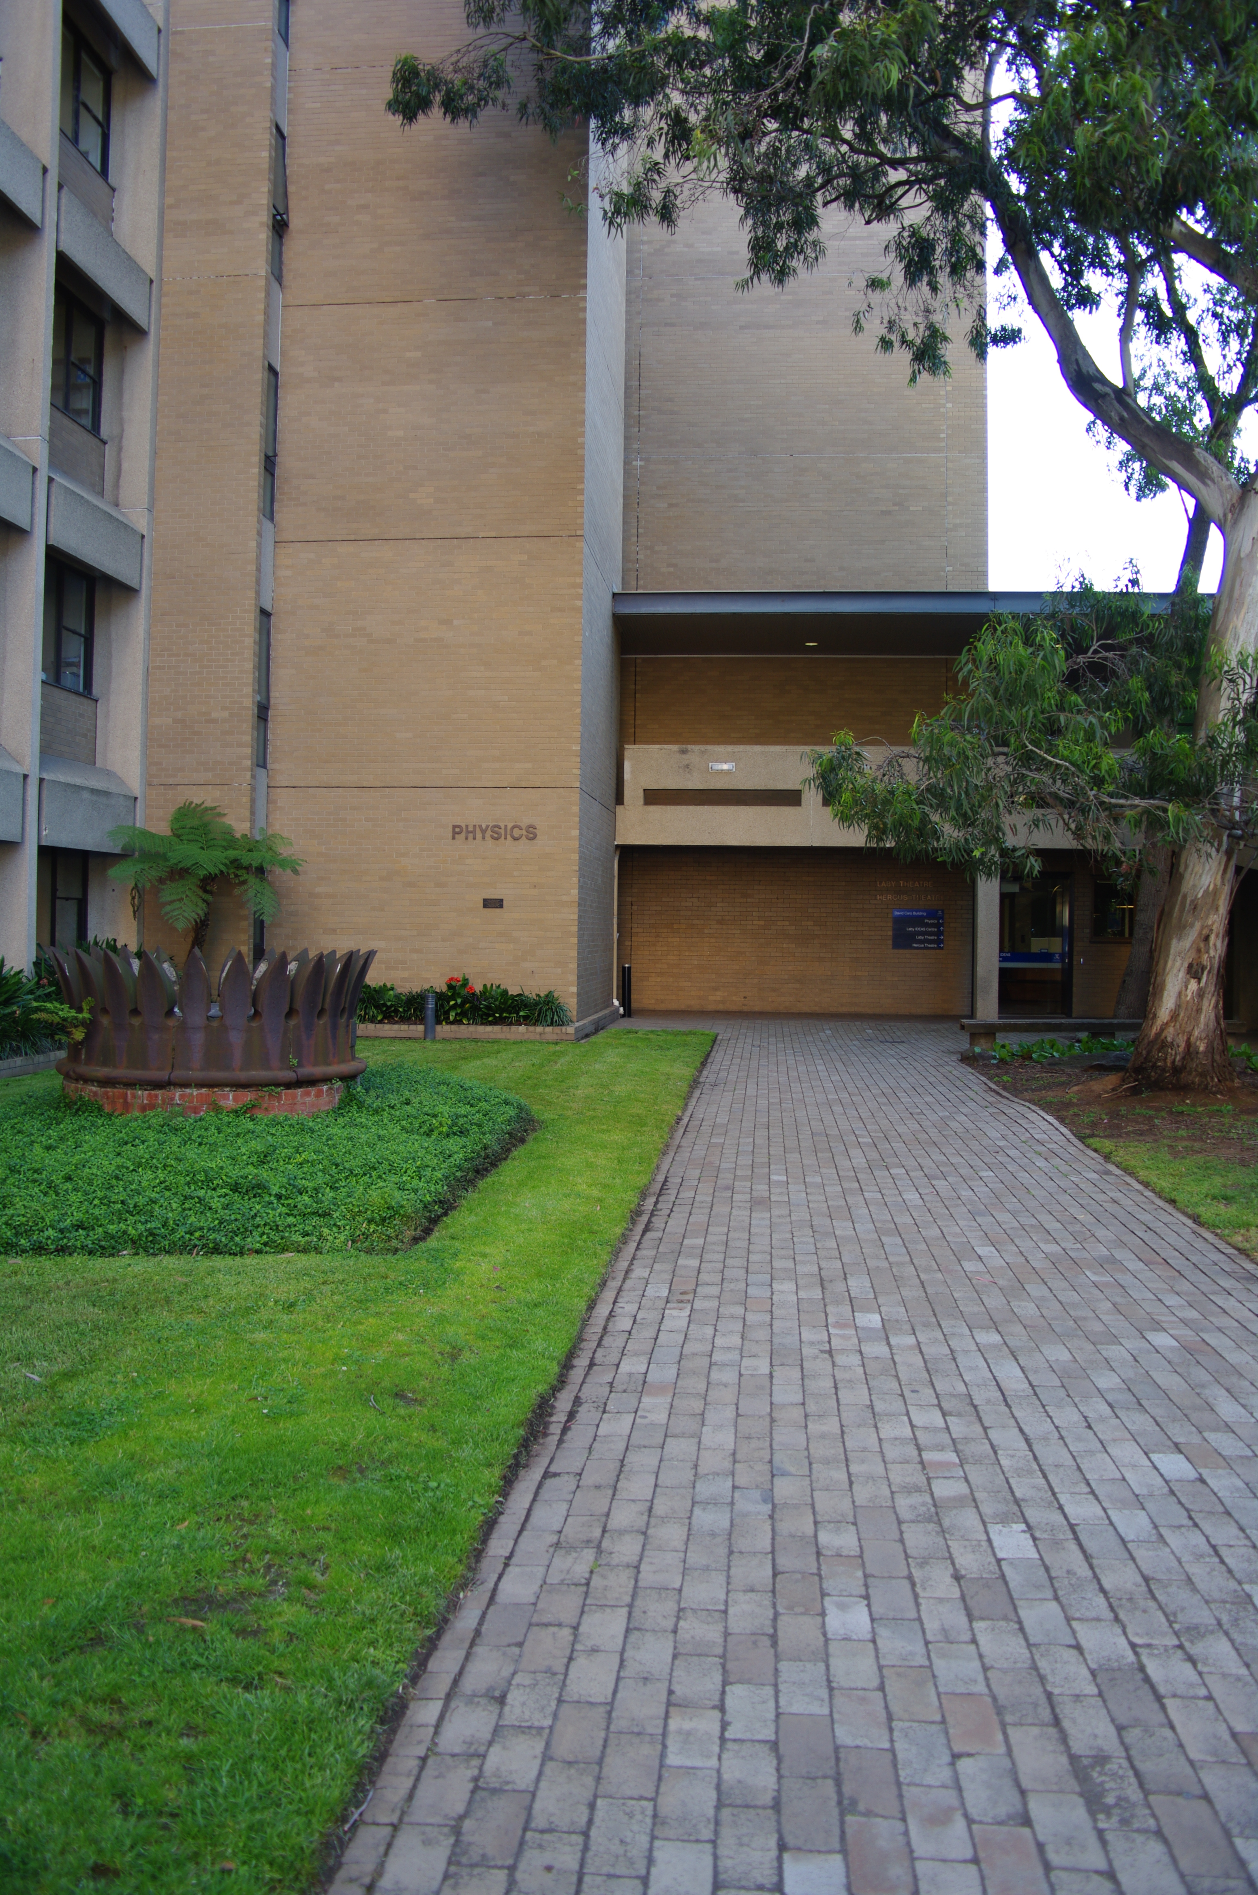
Poppy Gatsios
Chief Warden
Ext: 46246
  Chris Chantler  Chair of Safety Committee  Ext: 45437 | 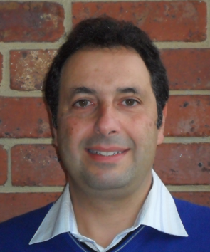  Sam Montalto  Faculty of Science  EHS Manager:  Ext: 46924 | 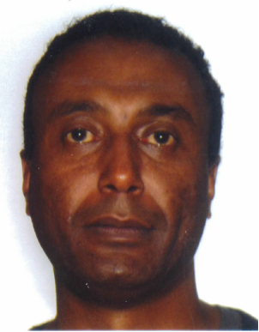  Melaku Alemu  OHS Coordinator  Ext: 49483
 | 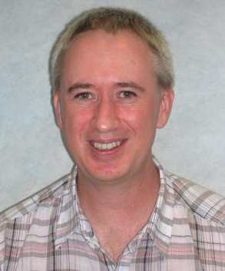 | 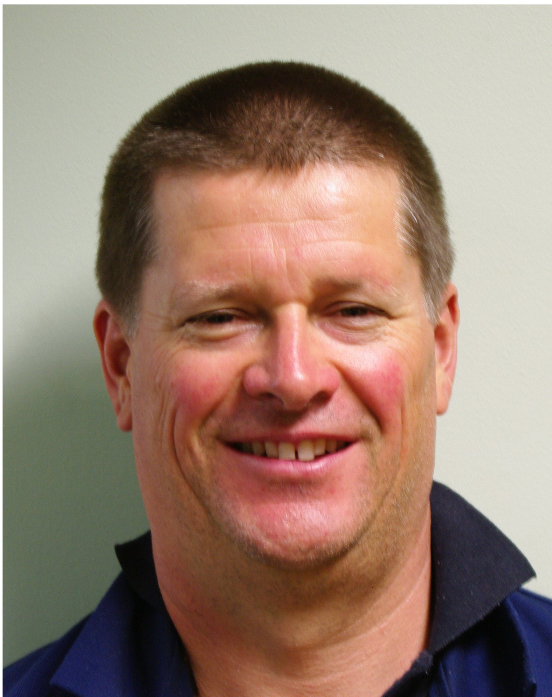
Shirley Els  Health & Safety Representative  Ext: 45453 | Colin Entwisle  Radiation Protection Officer  Ext: 48117 | Steven Damen  Laser Safety Officer  Deputy Chief Warden  Ext: 45425

Physics Safety Team

